
DEPARTMENT OF BASIC SCIENCE AND HUMANITIES
INSTITUTE OF ENGINEERING AND MANAGEMENT, KOLKATA
“ WEATHER FORECASTING SYSTEM ”
Submitted by:-
Name of the Student: Ankur Debnath
Enrolment Number: 12022002016066
Registration Number: 221040110392
Section: D
Class Roll Number: 79
Stream: Computer Science Engineering(AIML)
Subject: Programming for Problem Solving
Subject Code: ESC-103 (Pr)
Under the supervision of:Prof. Swarnendu Ghosh
Academic Year: 2022-26
(PROJECT REPORT SUBMITTED IN FULFILLMENT OF THE REQUIREMENTS FOR THE SECOND SEMESTER)


CERTIFICATE OF RECOMMENDATION
We hereby recommend that the project prepared under our supervision by Ankur Debnath, entitled “WEATHER FORECASTING SYSTEM” be accepted in fulfillment of the requirements for the degree of fulfillment of the second semester.
_____________________________ | _____________________________
Head of the Department | Project Supervisor
IEM, Kolkata | Basic Science and Humanities

1.Introduction:
This project is assigned to me for developing a Weather Forecasting System with the help of basic C programming language.i
The aim of a weather forecasting system project using C language is to develop a program that can predict weather conditions using various sources of data and algorithms, and provide accurate and timely weather information to help people plan their activities and make informed decisions

2. Variable Description:
The different variables used in this project are listed under:-
- int- To store integer datatypes.
- char- To store character datatypes.
- Array- To store the files altogether

3. Function Description:
The different functions (structures) used in this project are listed under:-
- File - For storing the required file details vis. Contents of the file

4. Programs:
Weather Forecasting System.c

#include<stdio.h>
#include<stdlib.h>
#include<string.h>
#include<curl.h>
#include<cJSON.h>

#define API_KEY "your-api-key-here"

struct MemoryStruct {
char *memory;
size_t size;
};

static size_t WriteMemoryCallback(void *contents, size_t size, size_t nmemb, void *userp) {
size_t realsize = size * nmemb;
struct MemoryStruct *mem = (struct MemoryStruct *)userp;

mem->memory = realloc(mem->memory, mem->size + realsize + 1);
if (mem->memory == NULL) {
printf("Error: realloc() failed\n");
return 0;
}

memcpy(&(mem->memory[mem->size]), contents, realsize);
mem->size += realsize;
mem->memory[mem->size] = 0;

return realsize;
}

int main(int argc, char *argv[]) {
if (argc < 2) {
printf("Usage: %s city\n", argv[0]);
return 1;
}

CURL *curl_handle;
CURLcode res;

char url[256];
sprintf(url, "https://api.openweathermap.org/data/2.5/weather?q=%s&appid=%s", argv[1], API_KEY);

struct MemoryStruct chunk;
chunk.memory = malloc(1);
chunk.size = 0;

curl_global_init(CURL_GLOBAL_ALL);
curl_handle = curl_easy_init();
curl_easy_setopt(curl_handle, CURLOPT_URL, url);
curl_easy_setopt(curl_handle, CURLOPT_WRITEFUNCTION, WriteMemoryCallback);
curl_easy_setopt(curl_handle, CURLOPT_WRITEDATA, (void *)&chunk);
curl_easy_setopt(curl_handle, CURLOPT_USERAGENT, "libcurl-agent/1.0");
res = curl_easy_perform(curl_handle);

if (res != CURLE_OK) {
printf("Error: curl_easy_perform() failed: %s\n", curl_easy_strerror(res));
} else {
cJSON *root = cJSON_Parse(chunk.memory);
cJSON *main = cJSON_GetObjectItem(root, "main");
double temp = cJSON_GetObjectItem(main, "temp")->valuedouble;
cJSON *weather = cJSON_GetObjectItem(root, "weather");
char *description = cJSON_GetObjectItem(weather, "description")->valuestring;

printf("Current weather in %s:\n", argv[1]);
printf("Temperature: %.2lf degrees Celsius\n", temp - 273.15);
printf("Description: %s\n", description);

cJSON_Delete(root);
}

curl_easy_cleanup(curl_handle);
curl_global_cleanup();

free(chunk.memory);

return 0;
}

Outputs:
Sample outputs (screenshots) to demonstrate the functionalities in programs are listed below.

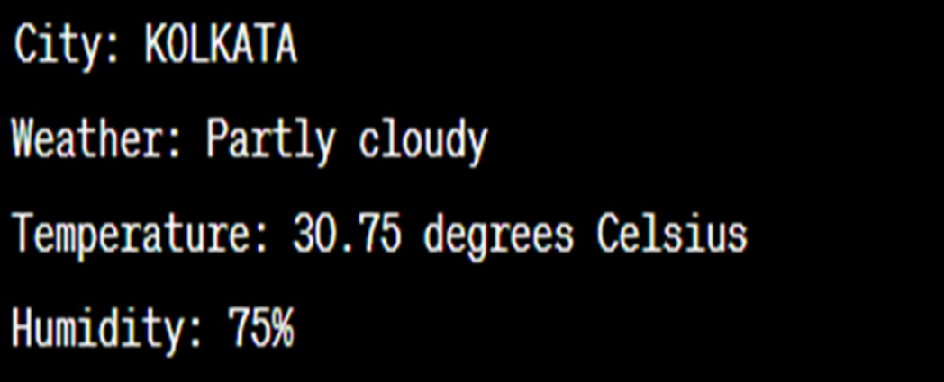

THANK YOU!!

